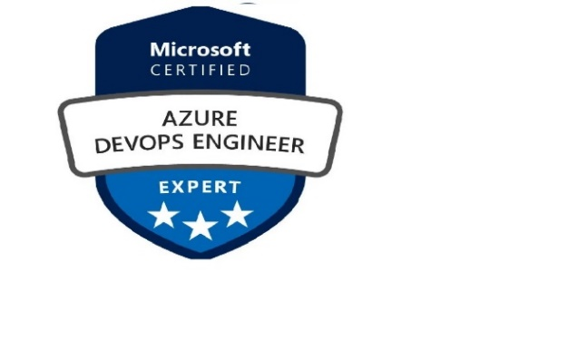

Career Objective
To be a part of the organization where I can utilize my knowledge and skills to the best of my ability and contribute to the organization growth in teams of technology and business.

Professional Summary

- Having 3.9 years of experience in the IT industry, hands-on experience with, Azure and Azure DevOps
- Involved in designing and deploying a multitude of applications utilizing almost all the Azure services (Including VNets, VM’s, Load balancer, Application gateway, NSG, Windows active directory, Storage accounts, log analytics, Web Applications.
- Implementing and Managing Virtual Networks, Cloud Services, ARM, Storage Accounts, and deploying Windows VMs through Management Portal, ARM, and PowerShell.
- Automating in azure for creation of Virtual Machines, Network, Storage Account, using PowerShell to run up the orchestrated environment. configuring Azure Virtual Networks, Gateways & Storage
- Created the CI/CD Pipeline in Azure DevOps for the .net, and UI based Web Applications.
- Hands-on experience in Branching and merging strategy.
- Configuring the CI/CD Pipeline based on the project requirement.
- Configuring CI/CD Pipeline in Azure DevOps for automating Azure Resources.
- Automation of infrastructure setup for environment through CI/CD.
- Experience in user access management in azure Through PowerShell and RBAC (Role Based Authentication & Control) as per requirement.
- Experience maintaining Teams and permissions for users in ADO.
- Experience in azure Pipeline access policies and cross repo policies
- Experience in config management of App services.
- Configuring Availability set, endpoints, and Load Balancing set as per the project requirement
- Configuring NSG’s to prevent and allow the specific network subnet
- Creation of Repos and managing files in repos for Build & release, managing of Version control for the application.
- Managing of Artifacts in release management and creating on Pipeline variables and variable groups.

Technical Skills: -

Cloud Technology | Microsoft Azure (IAAS, PAAS)
Azure Expertise | Virtual Machines, Virtual Networks, Web Apps, VPN Gateway, DNS,  Application Gateway, Load Balancer
Cloud Security | Azure Network Security Group’s
Data Storage | SQL Database, Azure Storage (Blobs, Tables, Queues Files and Disks)
Cloud Services | Azure Site Recovery, PowerShell, Microsoft Storage Explorer
DevOps Tools | Azure DevOps, GIT, ARM Templates
Identity & Access Management | Azure Active Directory
Web Servers | IIS
Operating Systems | Windows

Professional Experience
PROFESSIONAL EXPERIENCE:
PROJECTS UNDERTAKEN ()

Project#1  Client:  Role: Azure DevOps Engineer  Duration: | Roles and Responsibilities: -  - IaC using ARM Templates for PAAS Services Automation  - CI/CD using Azure DevOps.  - Git for Version Control system.  - Key Vault Configuration for storing the certificates, Secrets.  - Created and maintained several build definitions and publish Artifacts to handle automated builds in an Agile / SCRUM environment.  - Creating and configuring webapp’s with Build  Pipeline's and Release Pipelines.  - Configuring the CI and CD Pipelines for different Environment's  - Creating the vaults and Secretes and certificates from Key vaults.  - Taking care of Deployment as Release Admin, Release management Control's using the Pre- post deployment conditions and Gates  - Configuring the Variable group's for Build pipelines.

- Involved in AKS set up and deploy the code in Azure using AKS
- Created Test plans (Manual and Automation) and Test Suites for different Process (Basic and Agile)
- Infrastructure deployment automated using the ARM Templates
- Worked on Implementing the End-to-End DevOps
Project#2  Client:  Role: Azure PAAS Automation and VSTS(CI/CD)  Duration: () | Roles and Responsibilities: -  - Configuring the CI and CD Pipelines for different Environment's  - Taking care of Deployment as Release Admin,  - Release management Control's using the Pre-post deployment conditions and Gates  - Having good experience on TFS Up gradations  - Working on data Migrations from TFS to Azure DevOps  - Creating and configuring the Variables for Release pipelines.  - Creating the vaults and Secretes and certificates from Key vaults.  - Configuring the Variable group's for Release pipelines  - Created Test plans (Manual and Automation) and Test Suites for different Process (Basic and Agile)  - Involved in Organizational and project level Security and Administration  - Created Azure Boards for Tracking work items like user stories, bugs  - Coordinated software application and database deployments across several environments

Academic Profile

Certifications
  - AZ-400 Microsoft Azure DevOps Solution Expert
  - AZ-104 Microsoft Azure Administration
  - DP-203 Microsoft Azure Data Engineer Associate

Self - Assessment

